Brendan Mckenna, Cam Auler, Michael Pinelli

SEC335-01

9/3/2021

**Target**: Ben and Jerry’s

**Networks Identified - above Ip addresses**

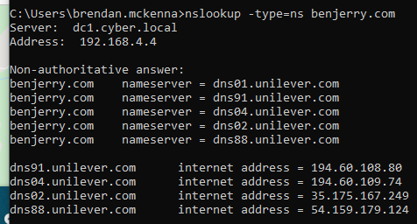

Registered Name servers for benjerry.com and their IP addresses, along with the IP address of the benjerry server.

**Hosts Identified**

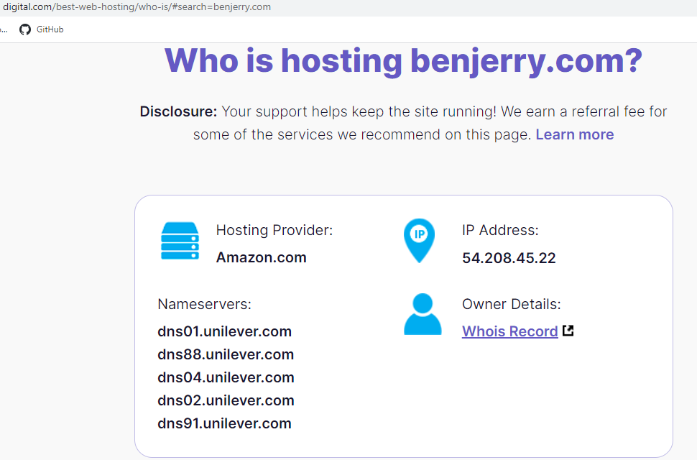

Host provider and IP address for benjerry.com

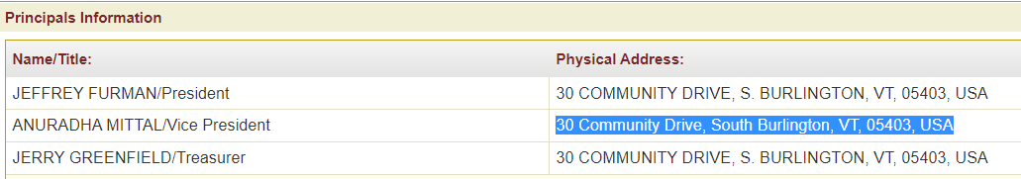

Individuals listed on bizfilings for a record of The Ben and Jerry’s Foundation Inc.

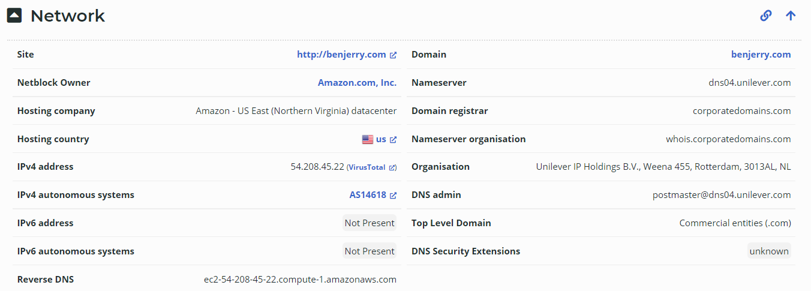

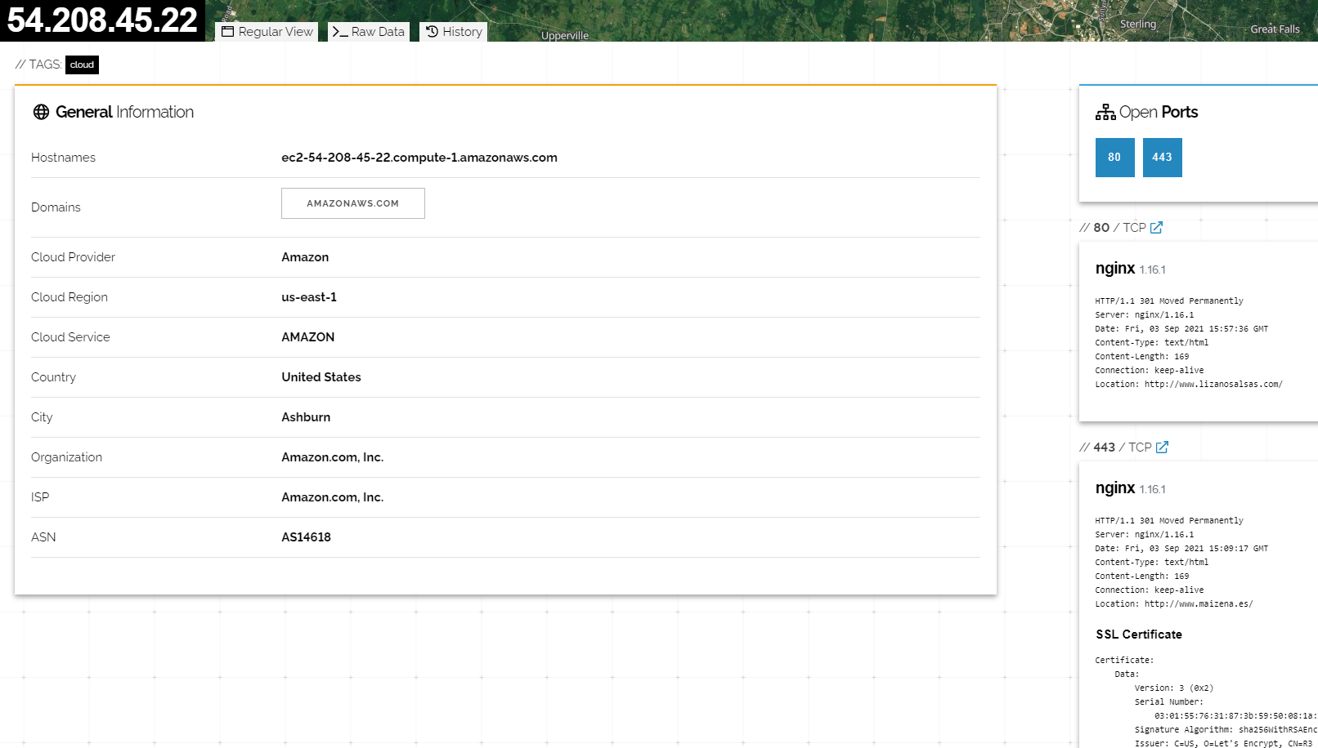Possible port vulnerabilities as well as location of physical server, the application being used and the SSL certificate.

**Applications and Security Systems**

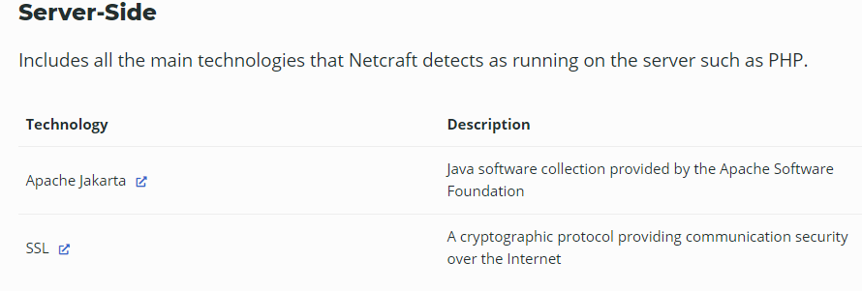

**Social Engineering Targets**

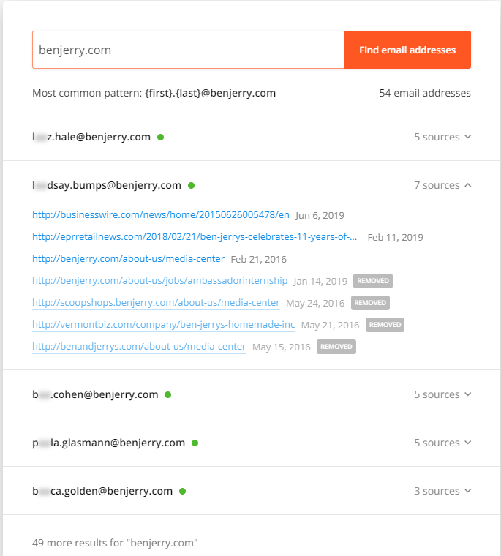

List of resources that provide emails connected to benjerry.com found on [hunter.io](https://hunter.io/)

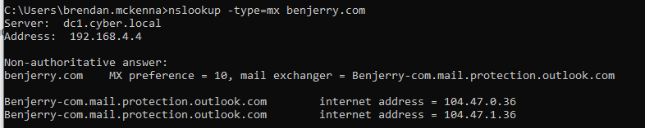

MX records for benjerry.com.